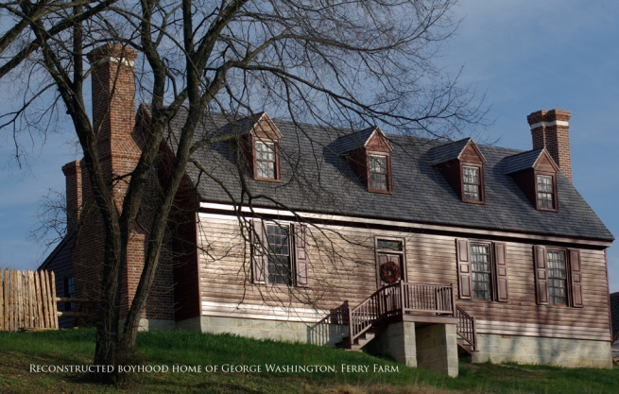
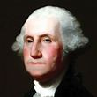
FERRY FARM

DATE: Saturday October 20, 2018
LOCATION: Carpooling from Dabbs
House Museum, 3812 Nine Mile Rd.
Henrico, VA 23223
TIME: 8:30 am
COST: $7.00

Boyhood home of George Washington
Itinerary:
8:30 am - Carpool departing Dabbs House Museum.
10:00 am - Arrival at Ferry Farm (268 Kings Hwy, Fredericksburg, VA 22405)
10:15 am - Tour of Ferry Farm
*11:30 am - Departure to Cracker Barrel Old Country Store Restaurant for lunch (located in the Central Park Shopping Center, 1971 Carl D. Silver Parkway Fredericksburg, VA 22401)
1:30 pm - Departure for return to Dabbs House Museum
3:00 pm - Arrival at Dabbs House Museum

------------------------------------------------------------------------------------------------------------------------------------------

REGISTRATION

NAME(S)______________________________________________________________________________
_____________________________________________________________________________________
ADDRESS_____________________________________________________________________________
PHONE NO.________________EMAIL ADDRESS______________________________________________
AMOUNT ENCLOSED @$7.00 P/P_________________________

Please MAKE CHECKS PAYABLE TO APHA and mail to 10213 Mobjack Ave., Glen Allen, VA 23060
Online registration is available at www.henricohistoricalsociety.org
*Please note, everyone is responsible for their lunch.
For additional information call (804)839-2407.

