Field Trip
Mount Airy & Menokin
Saturday, October 14
Mount Airy
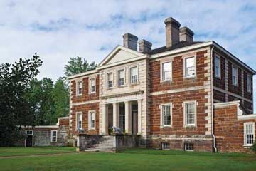
The land where Mount Airy is situated had been owned by the Tayloe family of Virginia since 1682. Colonel John Tayloe II, a fourth generation tobacco planter, began construction of the house around 1758 with completion in 1764. As a horse stud farm, several of racing heritage's greatest horses lived and were bred while at Mount Airy and owned or partly owned by John Tayloe II; including, Selima, Sir Archie and Grey Diomed. The original carriage house stable and a few outbuildings including a smokehouse, school house, counting room and dairy/ice-house stand to this day. The oldest surviving Orangery in North America is also located at Mount Airy.
Col. Tayloe's daughter, Rebecca married Francis Lightfoot Lee, a signer of the Declaration of Independence. A manor was built for them reportedly as a wedding gift by Col. Tayloe, known as Menokin.
The graves of Francis Lightfoot Lee and his wife Rebecca Tayloe who both died in 1797, are located in the Tayloe family cemetery on the Mount Airy estate. Brothers Francis Lightfoot Lee and Richard Henry Lee were two of seven signers of the Declaration of Independence from Virginia.
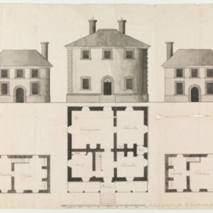
Menokin Described as the most engaging preservation project in America.
The plantation takes its name, Menokin, from the Rappahannock Indians who lived in the area prior to English colonization. (Scholars have suggested that the word "Menokin" may have been used by the Rappahannock Indians to mean "He gives it to me.") Additional work has involved the careful documentation and removal of collapsed wood, stone, and brick architectural elements from the house, and the recovery of small artifacts dating from the late eighteenth century through the 1940s.
Itinerary
8:30 - Departure Carpooling from Dabbs House Museum- 3812 Nine Mile Rd., Henrico VA 23223
10:00 - Arrival at Mount Airy
*12:00 - Lunch at Lowery’s Seafood Restaurant ( menu also includes non-seafood choices)
1:30 - Arrival at Menokin
4:00 - Arrival at Dabbs House
*Cost of $20 p/p covers admission/tour fees but does not include choice of lunch.

Registration

NAME(S)_____________________________________________________________________________________________
_____________________________________________________________________________________________________
ADDRESS_____________________________________________________________________________________________
_____________________________________________________________________________________________________
PHONE NO.__________________________________EMAIL____________________________________________________
AMOUNT ENCLOSED @ $20 P/P______________________
(COVERS COST OF ADMISSION/TOUR FEES BUT DOES NOT INCLUDE CHOICE OF LUNCH)

PLEASE MAKE CHECKS PAYABLE TO APHA AND MAIL TO:
10213 MOBJACK AVE.
GLEN ALLEN, VA 23060

